Cairo University Faculty of Computers and Information



**Software Engineering II**

**Software design specification document**

**2020**

**Project Team**

|  |  |  |  |
| --- | --- | --- | --- |
| **ID** | **Name** | **Email** | **Mobile** |
| 20170115 | Salma Essam Soliman | [ssalma.essamm@gmail.com](mailto:ssalma.essamm@gmail.com) | 01008097149 |
| 20170110 | Sarah Samer Moustafa | [ss.titanic199@stud.fci-cu.edu.eg](mailto:ss.titanic199@stud.fci-cu.edu.eg) | 01026991646 |
| 20170279 | Marriam Ahmed Amin |  | 01118403202 |
|  | Moustafa Khaled Moustafa |  | 01149324996 |

**[TA: Esraa Salem, TA: Mahmoud Haddad]**

Contents

Instructions [To be removed] 2

Class diagram design 2

Sequence diagram design 3

Github repository link 5

# Component Diagram

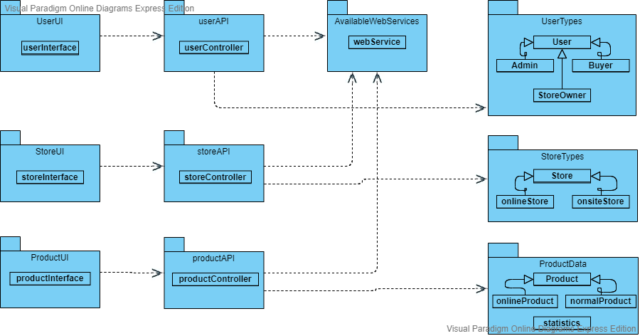

# Class diagram design

* **You should provide clean version for your class diagram design.**
* **Class diagram is a static diagram and should not represent any dynamic flow of events.**
* **Put Relationships between classes and the types of the relationships.**
* **Put multiplicity.**
* **Put relationship name (e.g. faculty "offer" course).**
* **Put attributes in the classes.**
* **Put functions & Put parameters.**
* **Put data types of each attributes and the parameters.**
* **Highly perfered: Each class has a corresponding interface**
  + **Let all objects parameters and returns be of interface type.**
* **See Shopping Cart Case Study**

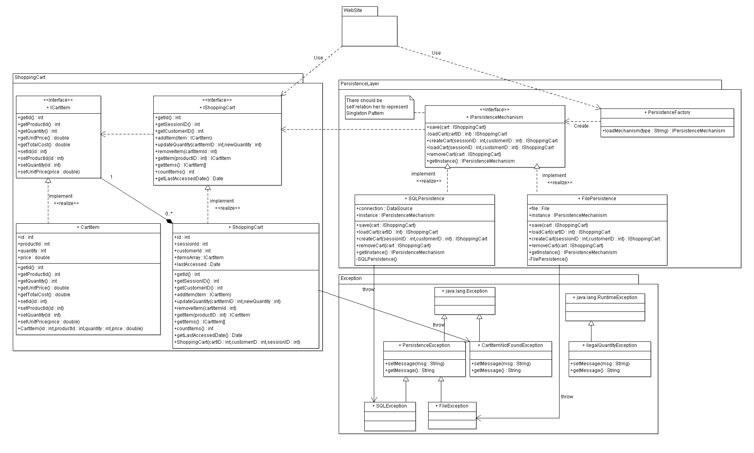

# 

# Sequence diagram design

Get List Sequence Diagram:

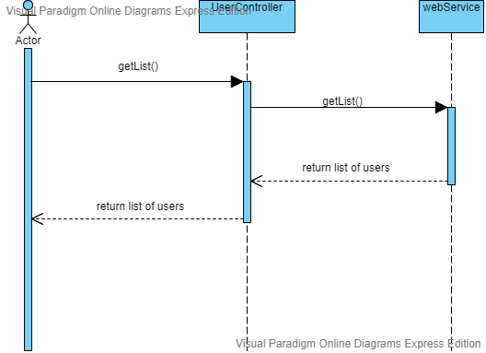

**Register User:**

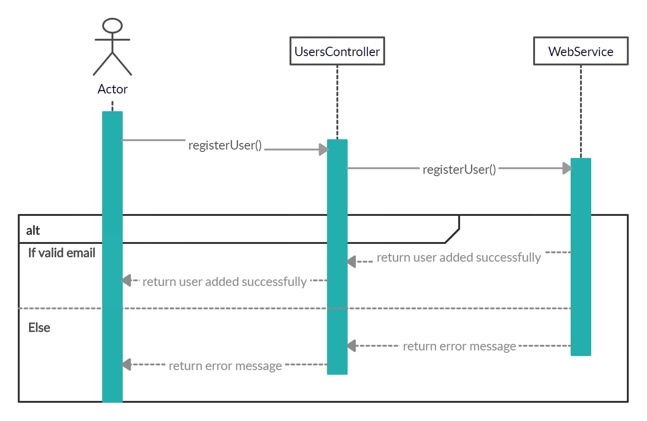

# Github repository link

* **URL for your repository, should contains implemented services**,